Shared Memory Systems
# Source: Chatgpt (GPT-5-Mini) at [1/16/2026]
A Shared Memory System is a type of distributed system in which multiple processes (or nodes) share a common memory space to communicate and coordinate, instead of sending messages.
This approach is used when processes are closely coupled and can access the same memory location to read or write data.

Definition
# Source: Chatgpt (GPT-5-Mini) at [1/16/2026]
A Shared Memory System:
- Provides a common memory area accessible by multiple processes
- Processes communicate by reading and writing shared variables
- Synchronization mechanisms like locks, semaphores, or monitors are needed to avoid conflicts

Architecture Diagram
# Source: Chatgpt (GPT-5-Mini) at [1/16/2026]
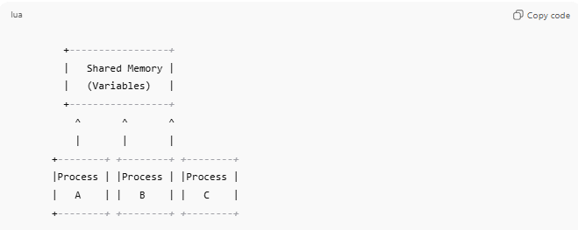
+-----------------+
| Shared Memory |
| (Variables) |
+-----------------+
^ ^ ^
| | |
+--------+ +--------+ +--------+
|Process | |Process | |Process |
| A | | B | | C |
+--------+ +--------+ +--------+
- All processes can access the same shared memory
- Processes must coordinate to avoid data inconsistency

Key Characteristics
# Source: Chatgpt (GPT-5-Mini) at [1/16/2026]
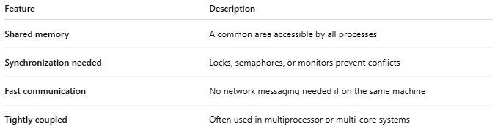
Feature | Description
Shared memory | A common area accessible by all processes
Synchronization needed | Locks, semaphores, or monitors prevent conflicts
Fast communication | No network messaging needed if on the same machine
Tightly coupled | Often used in multiprocessor or multi-core systems

How It Works
# Source: Chatgpt (GPT-5-Mini) at [1/16/2026]
- Processes access shared variables in memory
- They read or write data as needed
- Synchronization mechanisms ensure mutual exclusion
- Data is immediately available to all processes

Advantages
# Source: Chatgpt (GPT-5-Mini) at [1/16/2026]
- Fast communication compared to message passing
- Simple data sharing for tightly coupled systems
- Efficient for multiprocessor systems

Disadvantages
# Source: Chatgpt (GPT-5-Mini) at [1/16/2026]
- Difficult to implement over distributed networks
- Requires synchronization mechanisms to avoid conflicts
- Limited scalability beyond a single location
- Can be prone to deadlocks or race conditions

Examples
# Source: Chatgpt (GPT-5-Mini) at [1/16/2026]
- Multi-threaded applications sharing memory
- Multi-core processors in a single server
- Shared database buffers
- POSIX shared memory in UNIX/Linux systems

Simple Analogy
# Source: Chatgpt (GPT-5-Mini) at [1/16/2026]
- Shared Memory System: Multiple people working on one whiteboard
  - Everyone can write or read on it
  - They must take turns or coordinate to avoid overwriting each other’s work

